**Think and Answer**

**<Team ID>**

|  |  |
| --- | --- |
| **Team leader name** | Surbhi Kumari |
| **College** | Bharati Vidyapeeth College of Engineering |
| **Email** | itsmesurbhi27@gmail.com |
| **Date** | 24/11/2019 |

Please answer all the questions given below. You are allowed to use figures or diagrams to support your answer. Since these questions test your understanding of the whole subject, please refrain from directly asking for answers on Piazza.

**Section 1 - Simple Pendulum**

Q1) Find the eigenvalues of Simple Pendulum at equilibrium point (0,0). Is the system stable or unstable at this point? (2)

Ans.

Q2) Can the Pendulum be balanced at an arbitrary point such as (2π/3,0) using the Pole Placement or LQR controller? Why? Why Not? Justify your answer. (3)

Ans.

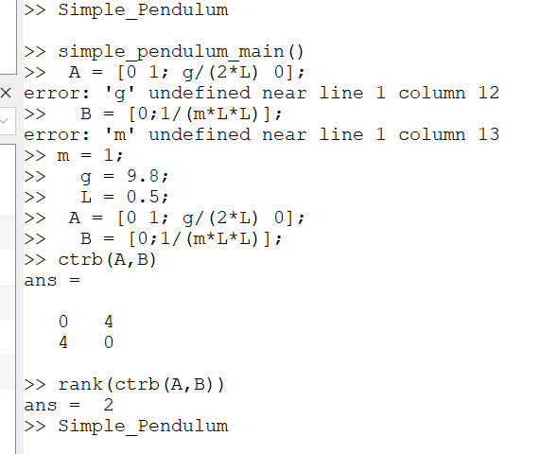

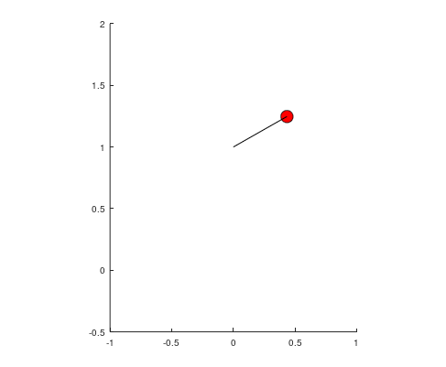

**Section 2 - Mass Spring System**

Q3) Derive the equations of Mass Spring system.

Ans. (3)

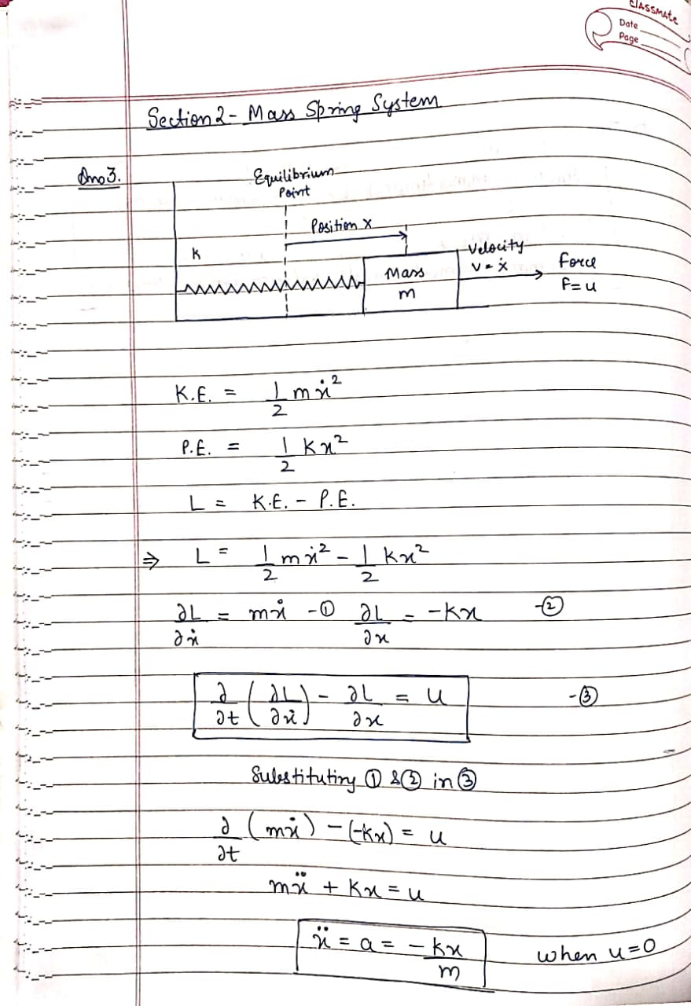

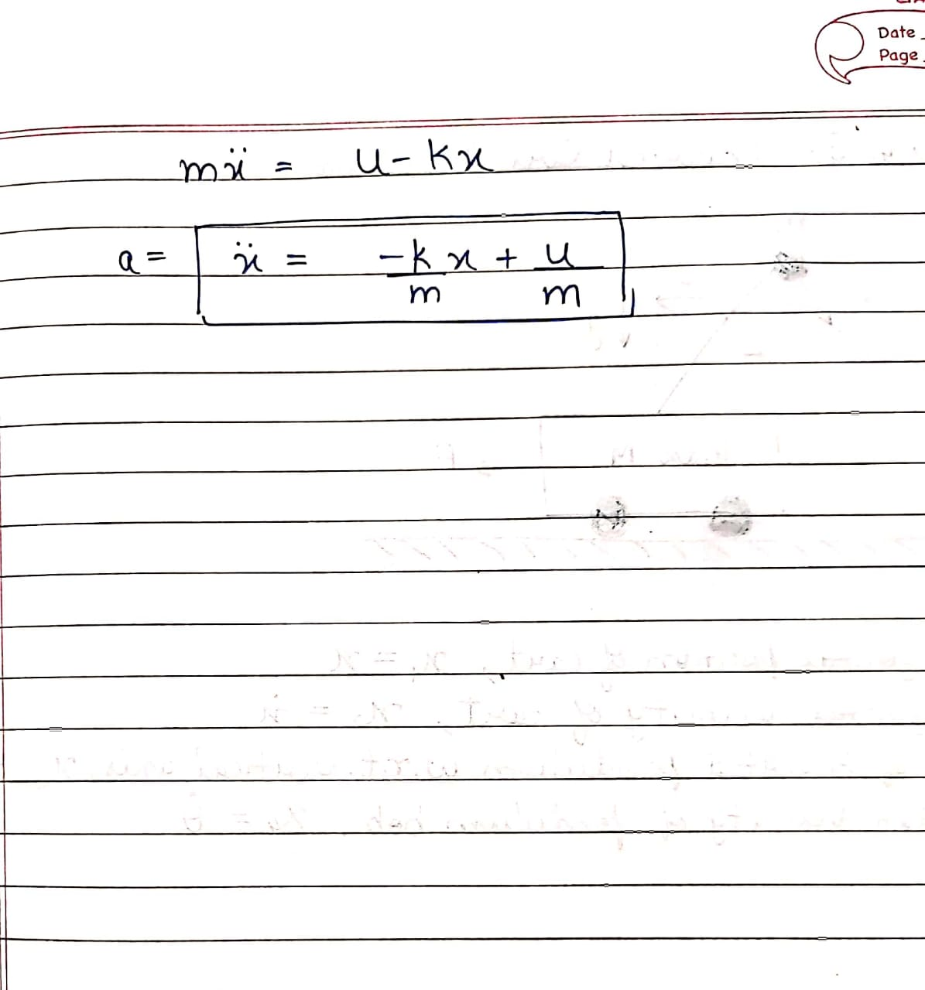

Q4) Is the mass spring system a linear system or non-linear? Justify your answer. (1)

Ans. The mass spring system is a linear system as the force exerted on the mass is directly proportional to the distance (x) moved by the mass from the mean position.

Q5) Can the mass spring system be driven to arbitrary state (0.8, 0) using pole placement controller? (Assuming 0.8 is the position and 0 is the velocity). (1)

Ans.

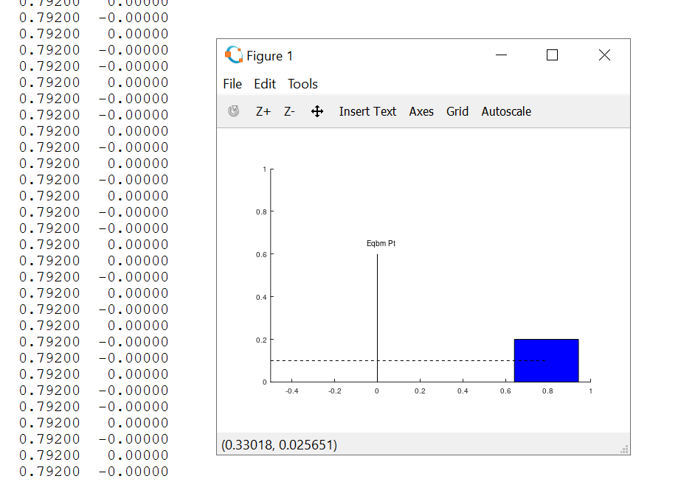

As seen from the image, we have brought the mass to an arbitrary point

**Section 3 - Simple Pulley**

Q6) Under what conditions, will the system remain perfectly at rest? Justify your answer. (1)

Ans. The simple pulley system will remain at rest when we consider the external force u = 0. Under this condition when m1 is equal to m2 i.e. both the masses are equal, the system will be at absolute rest.

Q7) How many equilibrium points does the system have? Are they stable or unstable? Justify your answer. (2)

**Section 4 - Complex Pulley**

Q8) Derive the equations of motion for the complex pulley system. (5)

Ans.

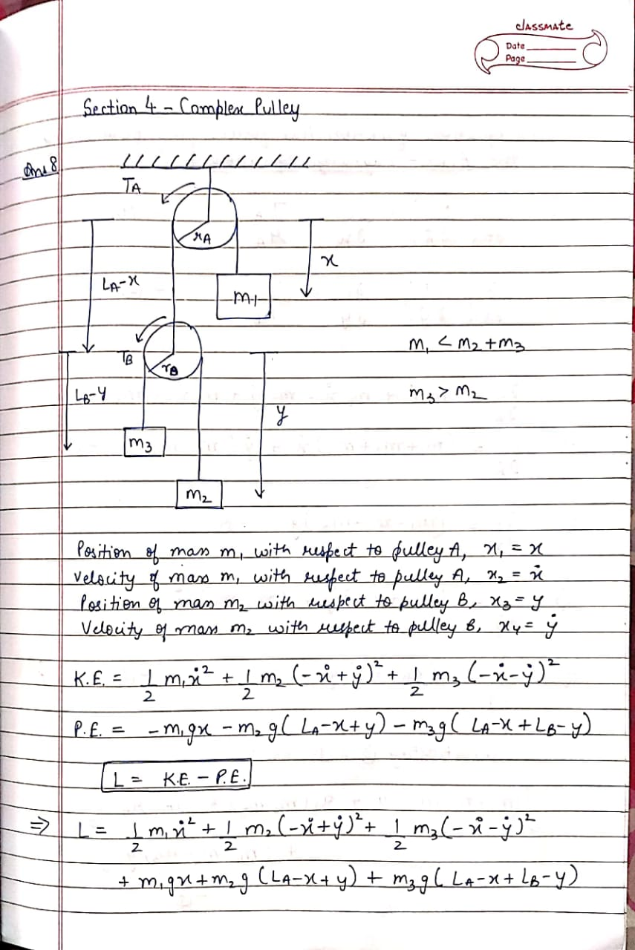

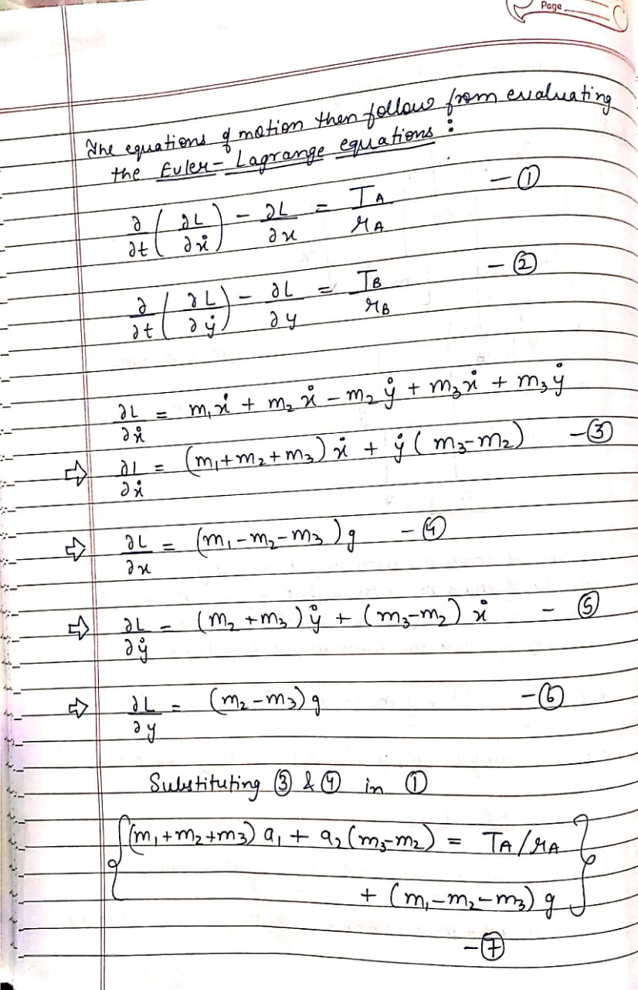

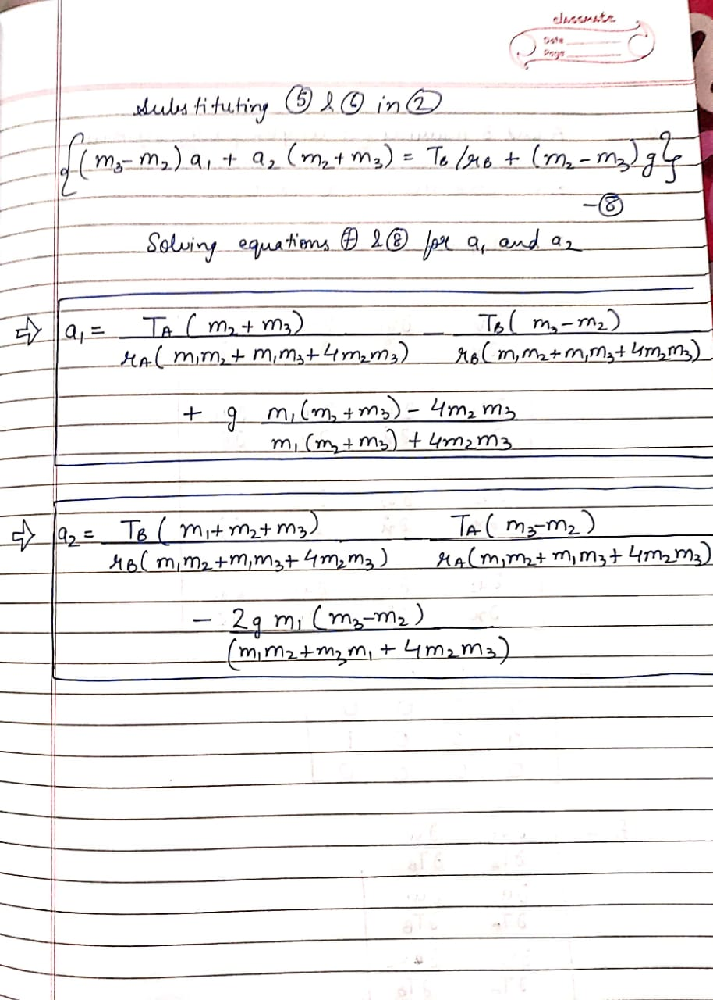

Q9) Derive the A and B matrices for the complex pulley system. Is the system linear or non-linear? (4)

Ans. 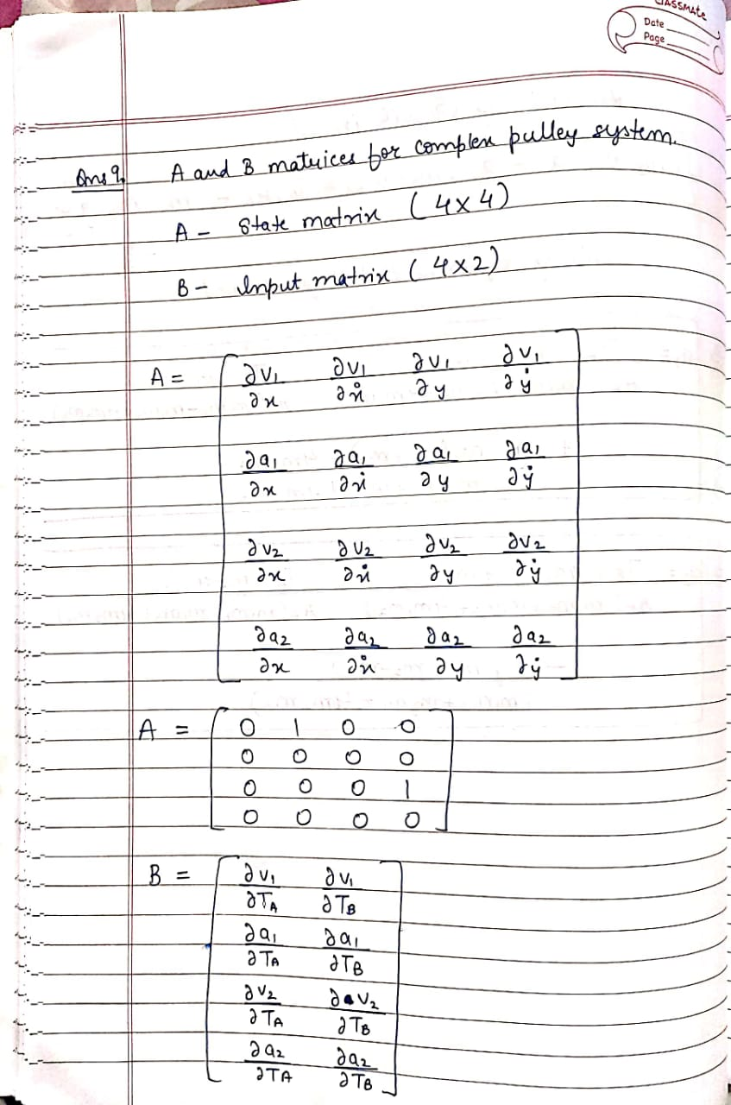

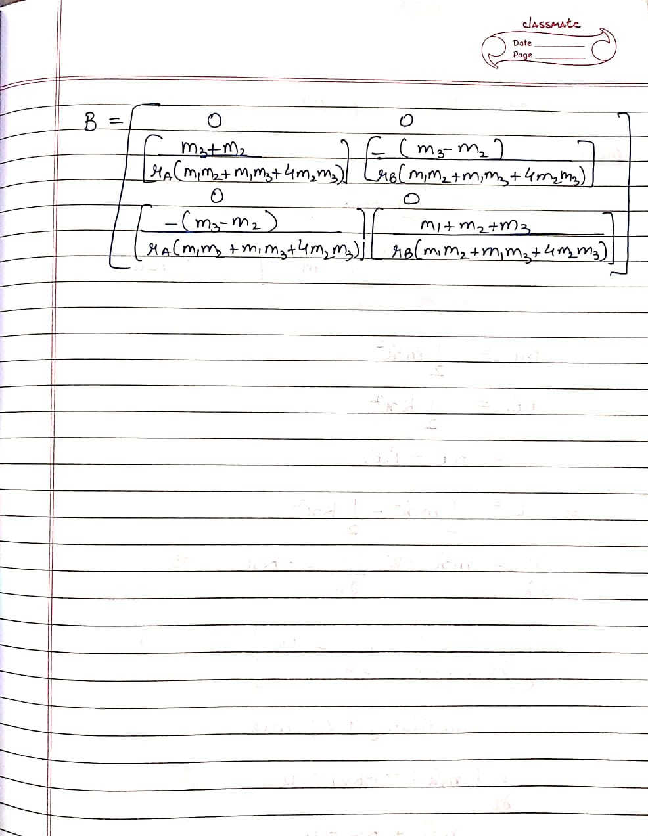

The system is linear as it is dependent on constant and predefined values like mass, radius and torque. It is independent of the distances travelled by the boxes.

Q10) Under what conditions, will the system remain perfectly at rest? Justify your answer. (3)

Ans. The complex pulley will remain perfectly at rest when the external forces i.e. the torques being applied on the pulleys (Ta and Tb) are zero. Under this condition from the acceleration equations we get

* (m1 x m3) + (m1xm2) = (4xm2xm3)
* m3 = m2

When these two conditions are obeyed, the system will remain at rest.

**Section 5 - Inverted Cart Pendulum**

Q11) Derive the equations of motion for the inverted cart pendulum system. Is this system linear or non-linear? Why? (7)

Q12) How many equilibrium points does the inverted cart pendulum system have? Categorize them as stable or unstable? (3)